Workflow is a model of a process an element in Pimcore goes through. In other words, it describes an object's life cycle. Each element in Pimcore can exist in multiple workflows simultaneously. Main features are derived from Symfony workflows.

Workflows are amazing for handling the life cycle of objects. It provides us with a way to manage an object through various states by not dirtying our classes with extra fields. Pimcore Workflows are based on Symfony workflows but there are some extra Pimcore-specific features. It also provides a graph view of the entire workflow and for this feature, Graphviz is needed as an additional system requirement.

## **Support strategies**

There are several ways to define which entities are supported by a configured workflow. This configuration is required and can’t be combined so you need to pick just one.

* supports – This is the simplest way to choose which entities are supported by workflow. It can be a single entity or array of entities
* Expression support strategy – This one is used when a workflow should be limited even in the entity class. By defining symfony expression, we can ensure that workflow applies to a certain type of entity. For example, if we have a product entity, we can limit workflow only to “more complex” ones like computers where we need to add all components and all information needed. And for something like a hard drive tray, we don’t want to use workflow because there is little data.
* Custom support strategy – If logic for limiting workflow is more complex, then you can even add the whole service as a strategy. Service needs to implement Symfony\Component\Workflow\SupportStrategy\SupportStrategyInterface.

**1- Create workflows.yaml file in config folder**

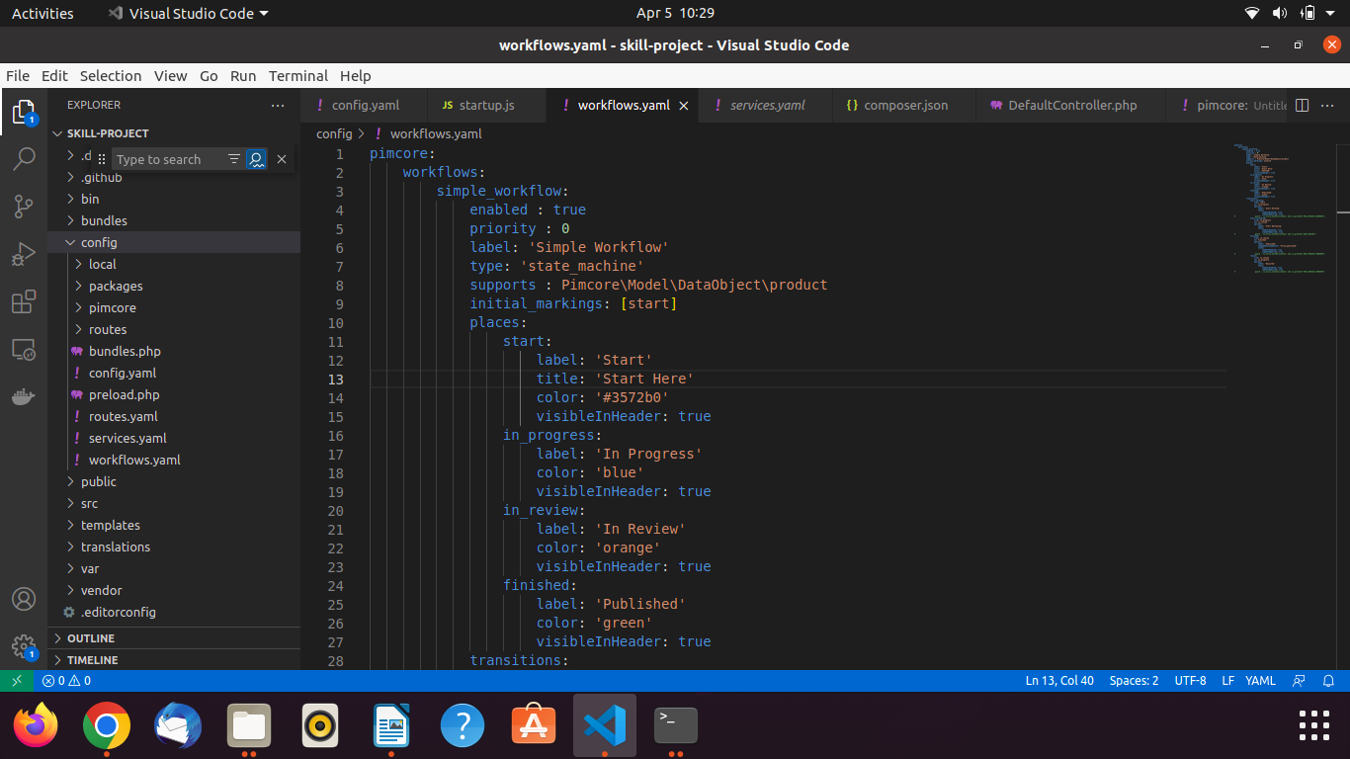

**Copy this code to new created file workflows.yaml**

pimcore:

workflows:

simple_workflow:

enabled : true

priority : 0

label: 'Simple Workflow'

type: 'state_machine'

supports : Pimcore\Model\DataObject\product

# support_strategy:

# type: "expression"

# arguments:

# - \Pimcore\Model\DataObject\

# - 'is_fully_authenticated()'

initial_markings: [start]

places:

start:

label: 'Start'

title: 'Start Here'

color: '#3572b0'

visibleInHeader: true

in_progress:

label: 'In Progress'

color: 'blue'

visibleInHeader: true

in_review:

label: 'In Review'

color: 'orange'

visibleInHeader: true

finished:

label: 'Published'

color: 'green'

visibleInHeader: true

transitions:

start_working:

from: start

to: in_progress

options:

label: 'Start Working'

notes:

commentEnabled: true

commentRequired: true

# guard : is_fully_authenticated() and is_granted('ROLE_PROJECT_MANAGER')

start_reviewing:

from: in_progress

to: in_review

options:

label: 'Start Reviewing'

notes:

commentEnabled: true

commentRequired: true

# guard : is_fully_authenticated() and is_granted('ROLE_EDITOR')

finished:

from: in_review

to: finished

options:

label: 'Published'

changePublishedState: "force_published"

notes:

commentEnabled: true

commentRequired: true

# guard : is_fully_authenticated() and is_granted('ROLE_PROJECT_MANAGER')

reject:

from: in_review

to: in_progress

options:

label: 'Rejected'

notes:

commentEnabled: true

commentRequired: true

# guard : is_fully_authenticated() and is_granted('ROLE_PROJECT_MANAGER')

pimcore:

workflows:

simple_workflow:

enabled : true

priority : 0

label: 'Simple Workflow'

type: 'state_machine'

supports : Pimcore\Model\DataObject\product

# support_strategy:

# type: "expression"

# arguments:

# - \Pimcore\Model\DataObject\

# - 'is_fully_authenticated()'

initial_markings: [start]

places:

start:

label: 'Start'

title: 'Start Here'

color: '#3572b0'

visibleInHeader: true

in_progress:

label: 'In Progress'

color: 'blue'

visibleInHeader: true

in_review:

label: 'In Review'

color: 'orange'

visibleInHeader: true

finished:

label: 'Published'

color: 'green'

visibleInHeader: true

transitions:

start_working:

from: start

to: in_progress

options:

label: 'Start Working'

notes:

commentEnabled: true

commentRequired: true

# guard : is_fully_authenticated() and is_granted('ROLE_PROJECT_MANAGER')

start_reviewing:

from: in_progress

to: in_review

options:

label: 'Start Reviewing'

notes:

commentEnabled: true

commentRequired: true

# guard : is_fully_authenticated() and is_granted('ROLE_EDITOR')

finished:

from: in_review

to: finished

options:

label: 'Published'

changePublishedState: "force_published"

notes:

commentEnabled: true

commentRequired: true

# guard : is_fully_authenticated() and is_granted('ROLE_PROJECT_MANAGER')

reject:

from: in_review

to: in_progress

options:

label: 'Rejected'

notes:

commentEnabled: true

commentRequired: true

# guard : is_fully_authenticated() and is_granted('ROLE_PROJECT_MANAGER')

**2- Now open the config.yaml file and paste the code**

imports:

- { resource: workflows.yaml }

As

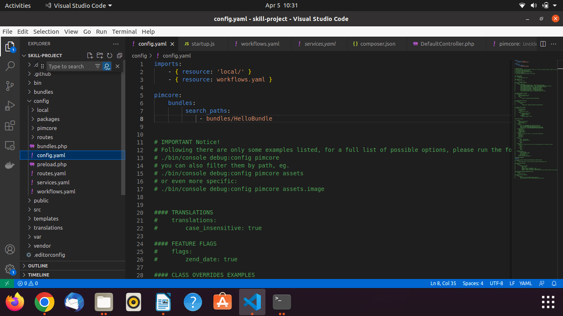

3- Now open the **Pimcore Admin** and **create the class**

And go to the **DataObjects** Tab and right click and select your class and make the object of that class.

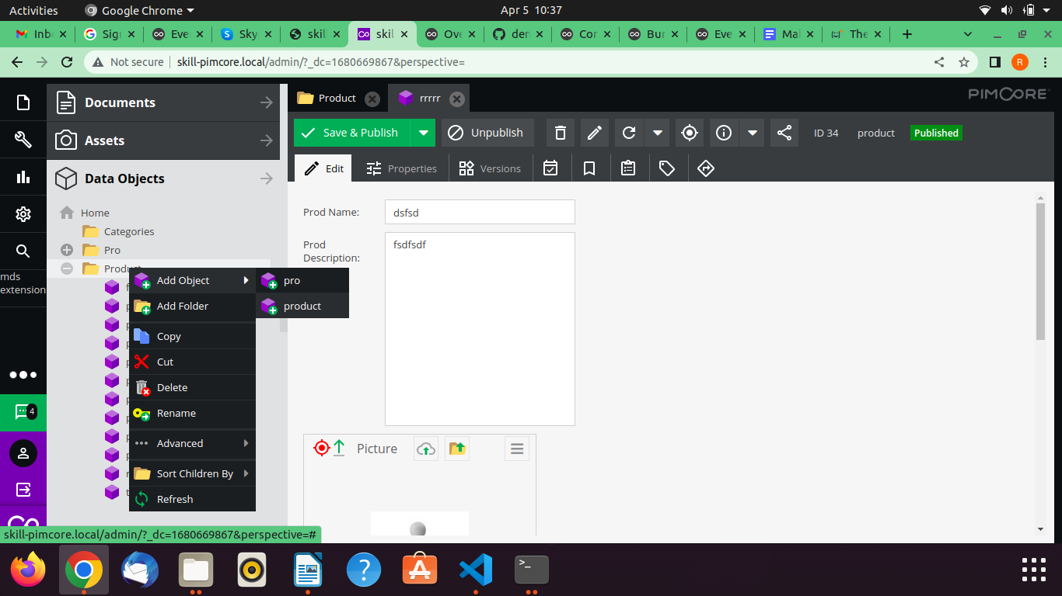

4- Finally see the Action button.

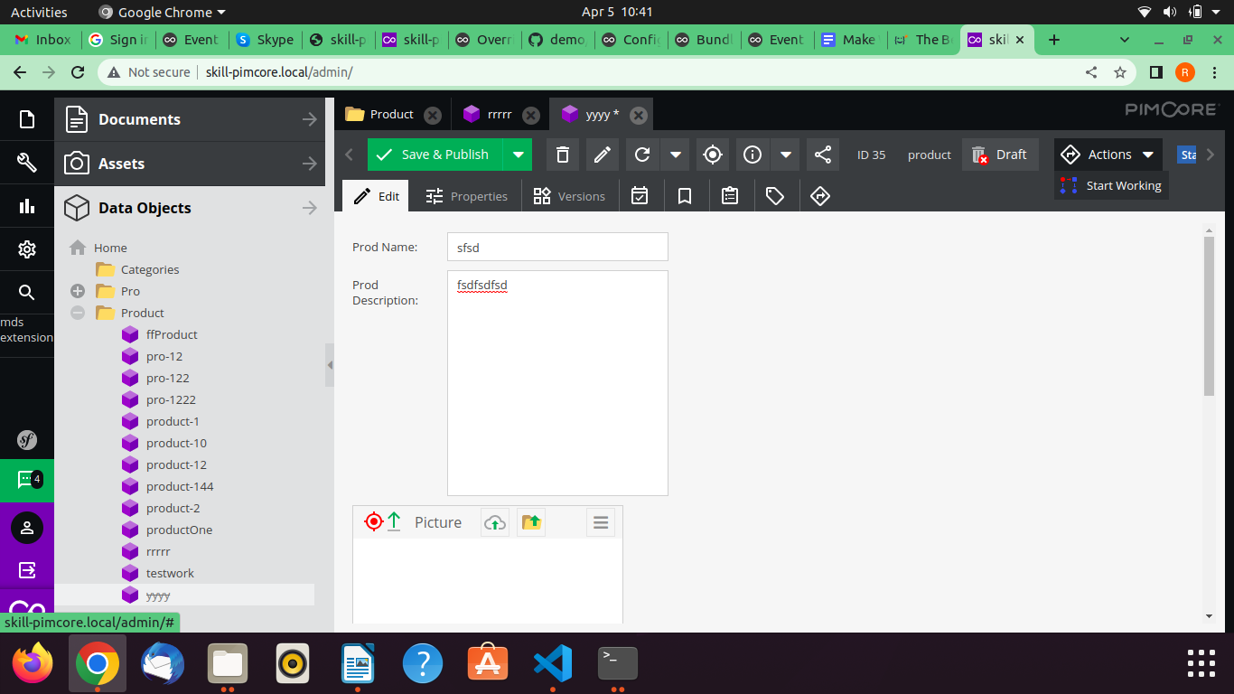

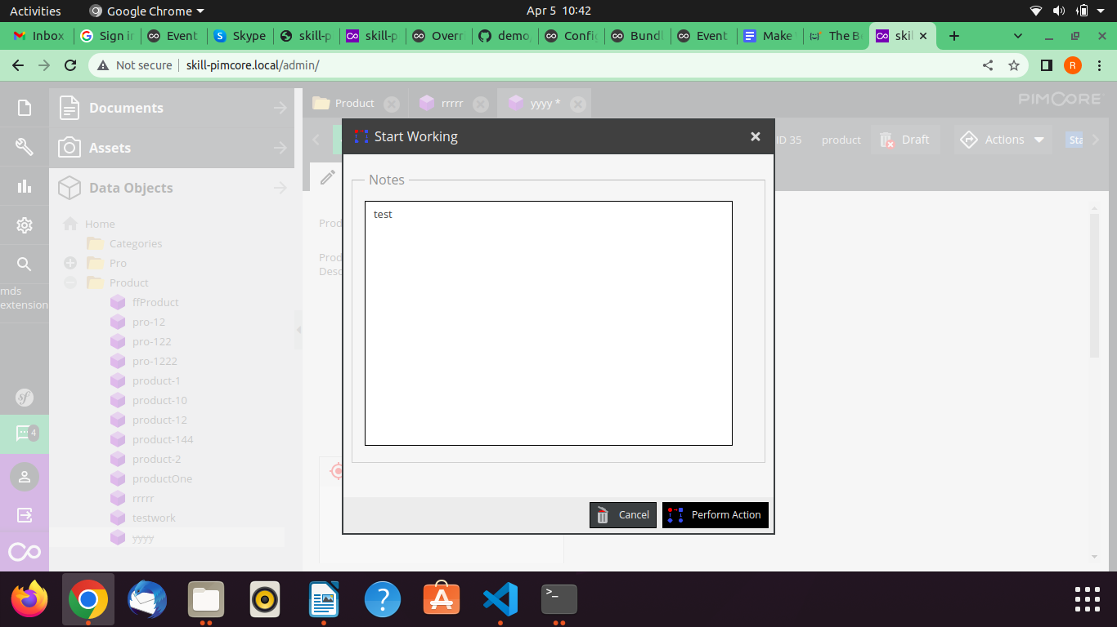

Click on **Perform Action** button and click on **Save and Published** button

Now click on the Action button and select Published button

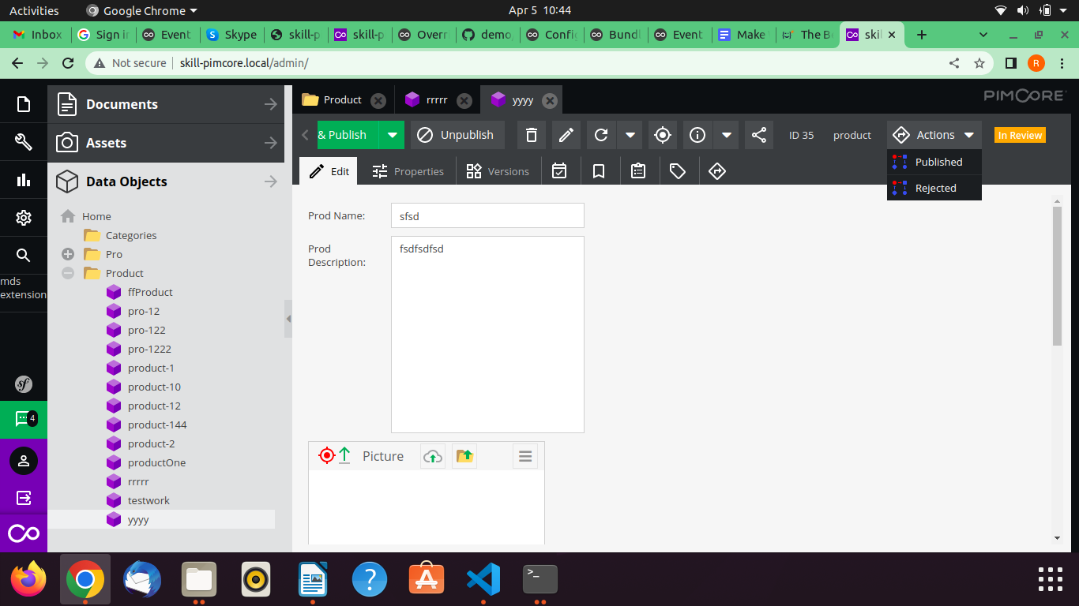

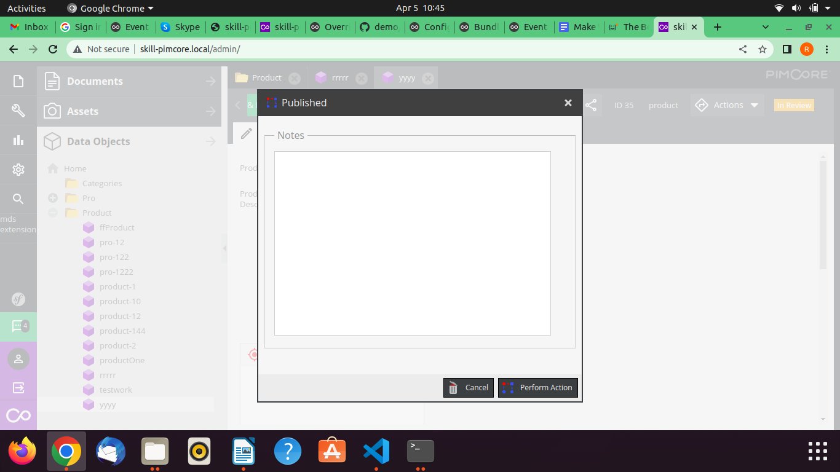

Type some comments and finally click on the **Perform Action** button.

